Air Quality 101
Colorado Department of Public Health and Environment
Air Pollution Control Division

What is air pollution?

What’s in the air?
The air in our atmosphere is composed of many, many things. In terms of gases, the atmosphere is primarily composed of nitrogen (78%), oxygen (21%), and argon (0.9%). These percentages do not change very much, and typically make up about 99.9% of the air we encounter. The remaining 0.1% is made of ‘trace gases’ and other things that are found in very small concentrations, but nonetheless have very important impacts on our environment, our day-to-day lives, and our health.

These fractional constituents can be ‘good’ or ‘bad’ depending on their concentration, location, desired effects, and the interaction that one has with them. For example, water vapor is one of the most highly variable gases in the atmosphere, ranging from 0-4% of atmospheric composition depending on time and place. This can be a ‘good’ thing as higher humidity is requisite for rain or snow, and thus contributes to precipitation patterns of the world, and delivers the water necessary for life on Earth. Conversely, water vapor is a greenhouse gas, and contributes to global warming/climate change. In these ways, water vapor in the atmosphere can be seen as either good or bad. However, water (and water vapor) specifically, is not a trace gas that we can do without, regardless of its concentration and one’s perspective on its effects. Other gases and particles in the air are not so harmless, though they may be found in far smaller quantities.

Think, so little can influence so much. The components that make up less than 0.1% of the atmosphere can produce big changes in our weather, our climate, and our health. Things like carbon dioxide (CO₂), methane (CH₄), and ozone (O₃) are greenhouse gases and act to retain heat within the atmosphere. The overabundance of these gases has led to more and more heat being ‘trapped’, and has begun to change the climate (or the long term weather average of a given location) of the Earth. These effects vary in outcome and magnitude in different places. Additionally, such things as ozone (O₃), nitrogen dioxide (NO₂), and fine particulate matter (PM₁₀ & PM_{2.5}), though generally in very small amounts, have the ability to negatively affect the health of plants and animals, including humans, typically through interactions like breathing and respiration.

Table 1. Primary gases and constituents of air and approximate (typical) concentrations found (measured) near the surface of the Earth.
Gas/Pollutant Name | Chemical Formula | Approximate Percent Volume | Approximate Composition Volume (ppb or µg/m³) at the Surface (Typical Conc.) | Threshold for 'Moderate' Air Quality/Time Period of Exposure (Averaging)
Nitrogen | N₂ | 78.08% | 780,840,000 ppb | N/A
Oxygen | O₂ | 20.95% | 209,460,000 ppb | N/A
*Water | H₂O | 0 to 4% | 0-40,000,000 ppb | N/A
Argon | Ar | 0.93% | 9,340,000 ppb | N/A
*Carbon Dioxide | CO₂ | 0.04% | 400,000 ppb | N/A
Neon | Ne | 0.00% | 181,800 ppb | N/A
Helium | He | 0.00% | 524000 ppb | N/A
*Methane | CH₄ | 0.00% | 179000 ppb | N/A
*Ozone | O₃ | 0.00% | 0-100 ppb | 55 ppb / 8 hours
*Carbon Monoxide | CO | 0.00% | 0-100 ppb | 9,000 ppb / 8 hours
*Nitrogen Dioxide | NO₂ | 0.00% | 0-75 ppb | 53 ppb / 1 hour
*Sulfur Dioxide | SO₂ | 0.00% | 0-3 ppb | 75 ppb / 1 hour
*Particulate Matter Smaller Than 2.5 Microns | PM_{2.5} | N/A | 0-50 µg/m3 (0-20,347,870 ppb) | 35 µg/m3 / 24 hours
* variable gases/ constituents | NAAQS Criteria Air Pollutant

Where does air pollution come from?

There are 4 general categories for air pollution sources, these are:

Mobile sources – such as cars and trucks, buses, planes, and trains 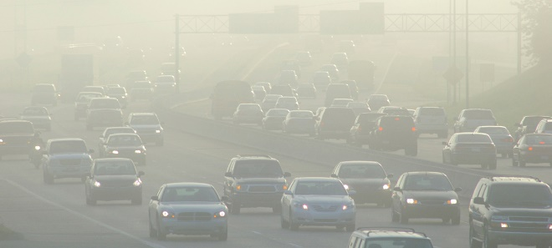

Stationary sources – such as power plants, oil refineries, industrial facilities, and factories
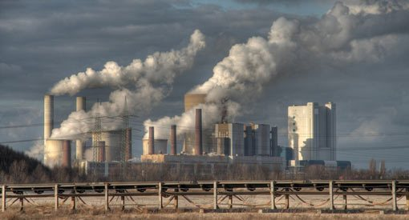

Area sources – such as agricultural areas, cities, and wood burning fireplaces
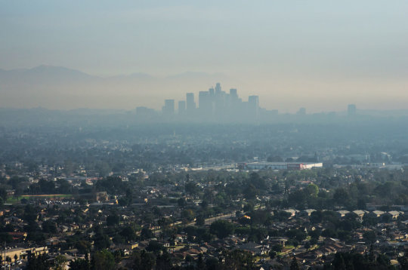

Natural sources – such as wind-blown dust, wildfires, and volcanoes
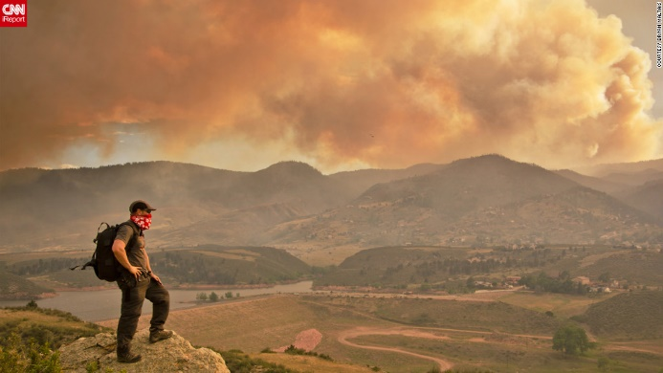
Specifically, what things/activities/sources produce air pollution?
In short, industrial activities and automobiles are the greatest sources of air pollution. Gas powered engines and emissions from factories and industrial operations are highly regulated and monitored, but sometimes other things can influence how much they put out, how harmful it is to public health, and if the pollution gets carried away with the wind or hangs around close to where we live.

Sources of air pollution are diverse, change, and sometimes it’s not very clear exactly where the pollution comes from. This is because some of the pollutants that are most prevalent do not come directly from pollution sources—this is to say that molecules that are emitted at these sources may combine with other things in the atmosphere to become the pollution that affects us. These things are called precursors as they are the things that ‘come before’ the pollution that we are talking about. These precursors make it possible for the reactions to take place that result in the pollution we experience or measure. In this sense, the direct source of air pollution can sometimes be a bit of a mystery. For example, ozone precursors are often emitted in the form of nitrogen oxides (NOx) and Volatile Organic Compounds (VOC’s) and undergo reactions in the atmosphere that result in the formation of ozone.

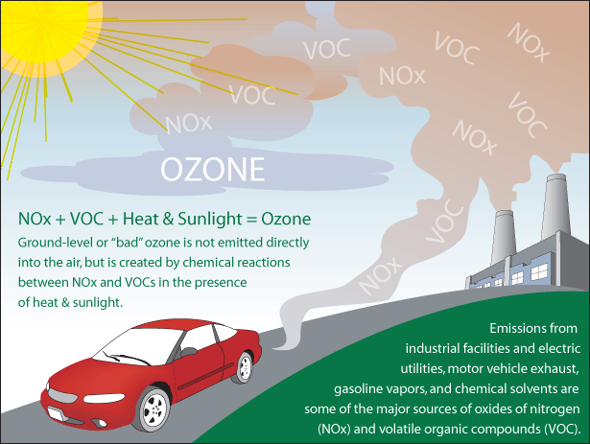
Image source: https://airnow.gov/index.cfm?action=aqibasics.ozone

However, these precursors have been studied extensively and are fairly well known, so we sometimes refer to the sources of these as being pollution sources, even though it’s not always that clear.

The main sources of air pollution in Colorado (and most places) are industry and transportation. Some industries produce more of one pollutant than another, and others produce more NOx and/or VOCs and contribute more to pollution by providing precursors that lead to the formation of pollution, rather than producing the pollution itself. Single sources that produce lots of pollution or precursors are known as major sources, but they’re not the whole of the issue.

In addition to major sources there are many, many small sources that lend to the problem and create large amounts of pollution through their sheer numbers, even though each source is fairly small. The collection of these minor sources add together to create area sources. That’s why it is important to recognize all of the contributions to air pollution, no matter how small they may seem.
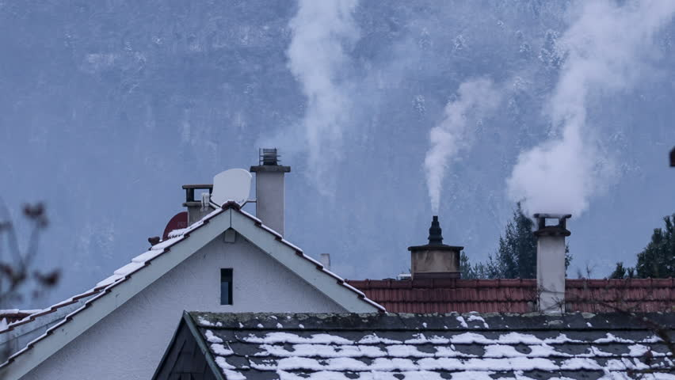

Each fireplace that emits smoke, each can of solvent in a garage that is not tightly capped, each spill of a few drops of gasoline as we fill the tank of our car, or each lawn mower (that runs on gas) on a hot summer day—all of these things add up like the straw that broke the camel’s back, and contribute to the problem of air pollution.

This sounds complicated and confusing. How do I know if I should be concerned about the Air Quality?

In order to simplify messaging during times when air quality is of concern, the Environmental Protection Agency (EPA) has created a number/color based index for the communication of concerns to the public. The Air Quality Index (AQI) is a way of letting folks know when the air is potentially unhealthy, regardless of which pollutant is of greatest concern at that time. The chart below shows when things are Good (AQI <50), Moderate (AQI 50-100), Unhealthy for Sensitive Groups (AQI 101-150), and so on. Each pollutant has a different concentration and time period of averaging for calculation of AQI for that pollutant, but just knowing the AQI numbers and colors will tell you if the air quality is Good, or if it’s best to take it easy or stay inside for your exercise.

The Air Quality Index uses numbers and colors to represent and communicate air quality. Being familiar with the AQI can help to stay alert and aware of air quality concerns in your area.
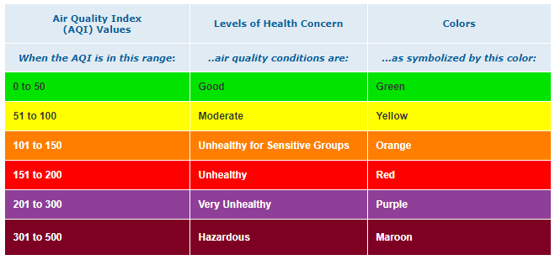

How does it affect me?

Why do we care? What is of concern?
Here in Colorado, the Colorado Department of Public Health and Environment (CDPHE) keeps a watch out for several pollutants that can harm us, including all EPA defined NAAQS Criteria Pollutants. We have monitors that give us the concentration of ozone, fine particulates, nitrogen oxides (NO, NO₂), sulfur dioxide (SO₂), and carbon monoxide (CO) in various locations around the state.

Most of these pollutants affect the cardio-pulmonary and respiratory systems of the body, and so, are most influential to people who are at risk for heart and lung ailments. So, those who have asthma, COPD (Chronic Obstructive Pulmonary Disease; i.e. bronchitis or emphysema), lung disease, and heart disease, as well as other pre-existing conditions that may relate to these ailments, will be more vulnerable to these effects and often are the first to know that they are being affected. However, other populations are at risk too, like those with still-developing bodies, such as babies and teenagers; and those with reduced abilities to overcome adverse health conditions, such as the elderly. With high enough concentrations of pollutants, extreme exposure (heavily respirating individuals like athletes), and prolonged exposure can affect even healthy adults.

The health effects of air pollution exposure can range from mild to severe, and can be a bit different based on the pollutant that a person is exposed to. The following are the most common symptoms that can be expected from each of the most common pollutants that we see reach potentially harmful levels here in Colorado:

**Many of the symptoms of exposure for outdoor pollutants, particularly during early onset, are similar, and typically include respiratory inflammation and irritation, especially for at-risk individuals.

Table 2. NAAQS pollutants and the symptoms and possible health impacts of exposure to each.
Pollutant | Mild Symptoms | Potential Severe Health Effects
Ozone (O₃) | Respiratory inflammation  Breathing difficulty  Asthma attacks | Lung damage  Early death
Fine Particulate Matter (PM_{2.5}) | Respiratory inflammation  Breathing difficulty  Asthma attacks | Heart attack(s)  Stroke(s)  Early death
Nitrogen Dioxide (NO₂) | Respiratory inflammation  Coughing  Wheezing  Difficulty breathing  Asthma attacks | Development of asthma  Increased susceptibility to respiratory infections
Carbon Monoxide (CO) | Dull headache  Weakness  Dizziness  Nausea or vomiting  Shortness of breath  Confusion  Blurred vision | Loss of consciousness  Death
Sulfur Dioxide (SO₂) | Respiratory irritation ( nose, throat, airways)  Wheezing,  Shortness of breath  Tight feeling around the chest | Decreased respiration  Inflammation/infection of the airways  Destruction of areas of the lung  Decreased lung function

Carbon monoxide poisoning can be particularly dangerous for people who are sleeping or intoxicated. People may have irreversible brain damage or even die before anyone realizes there's a problem. However, high concentrations of carbon monoxide typically occur in confined spaces and are unusual outdoors. CDPHE almost never sees elevated levels of CO on our outdoor air pollution monitors.

I’m not asthmatic, and no one I know is, so why should I care?
To begin, high enough concentrations of any pollutant can become hazardous to everyone’s health, not just vulnerable people. Also, prolonged exposure to lower levels of some pollutants can also have serious or lasting health impacts. However, in addition to direct impacts on human health, air pollution can have negative consequences in other ways.

Aside from protecting human health (even if you don’t know them) air pollution is detrimental to other animals and plants too. Remember, your dog and cat also breathe the same air you do, so if it’s not good for you, it’s probably not good for them. But the problem extends well beyond those who respirate with lungs only. Plants also respirate, just not the same way that we do, and many of these same substances also hurt plants. Ammonia (NH₃) and ozone, are directly harmful to plants as they are consumed through direct air-plant interactions, and nitrogen dioxide and sulfur dioxide can also create acid rain when they interact with precipitation, and this can really harm plants as it falls on them directly or as it is taken up by the roots of plants. Acid rain also affects the water in lakes, streams, and rivers, and can harm or kill the plants and animals that live there too. While air pollution may begin by being in the air, it quickly finds its way into the water and soil too.
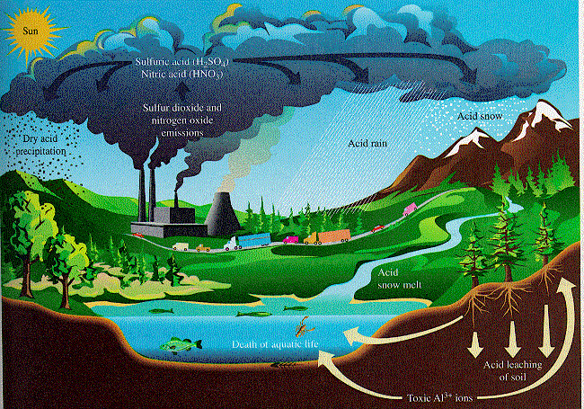
Image Source: http://savepost.blogspot.com/2013/04/acid-rain.html

In these ways, trees, farmland crops, backyard gardens, lakes, rivers, and streams, and all of the fish and aquatic life that live in them can all be impacted by air pollution; directly or indirectly. Again, these little things may all add up to larger consequences, some of which are difficult to realize before they take place unintentionally.

How are air pollution standards established, how is it measured?
The National Ambient Air Quality Standards (NAAQS) are defined by the EPA and set the standards for how much of each pollutant is acceptable to be present for a given period of time, based on human health studies. The CDPHE has several monitors that measure all NAAQS pollutants at various locations throughout the state of Colorado. A team of regulators, monitoring technicians, modelers, and meteorologists work hard to keep track of air pollution in our state, and warn the public if unhealthy levels of pollution are taking place or are expected.
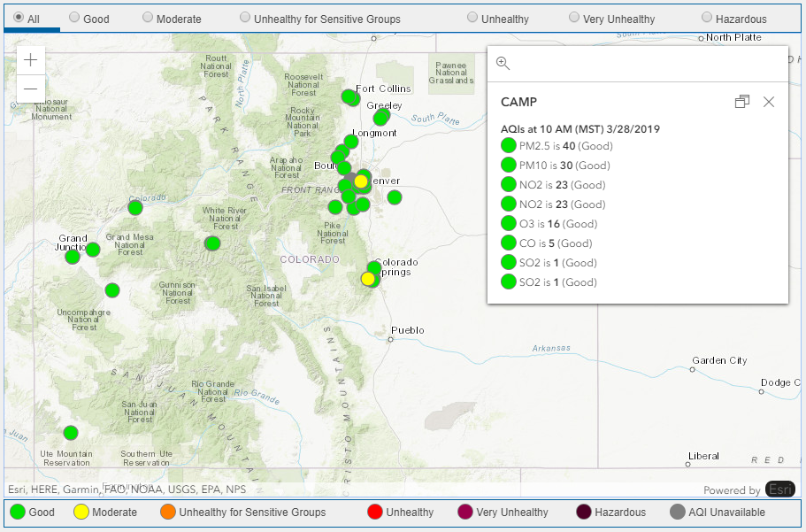
This map shows the locations of air quality monitors throughout the state of Colorado, and an example of how AQI for each pollutant is displayed at one site (the CAMP site, located in downtown Denver). The interactive map can display current air quality information in your area, and can be accessed at: https://www.colorado.gov/airquality/all_sites_map_ags.aspx.

How is air quality and AQI communicated? How is it available to me?
The EPA developed the Air Quality Index (AQI) in order to simplify the communication of when the air is potentially hazardous to public health. The use of this numerical scale and its associated colors helps to know when to reduce activity and take precautions to protect against exposure to health risks. Both the EPA and the State of Colorado, through the CDPHE have resources designed to keep you informed about current and future air quality concerns. The following websites can be used to keep up with air quality, and to know when actions should be taken to protect the health of yourself, your community, and your environment. Check out the air quality measurements, AQI calculations, and other information at:
https://www.colorado.gov/airquality/
https://www.epa.gov/outdoor-air-quality-data
https://airnow.gov/

What can I do to protect myself or minimize exposure?
Minimizing health risks associated with air pollution can often start with awareness. This may be as simple as knowing when is best to exercise outdoors. Finding better times to exercise can help a lot to reduce exposure. Unfortunately, some pollutants can pose a health risk even when you’re indoors. For these, having specialized filters is needed to properly reduce risks. Knowledge and awareness of air pollution and how it can affect you is really a great way to start reducing your exposure. Even for the most persistent of pollutants, there are ways to minimize impacts—some may require more effort than others—but action can be taken to help protect your health.
Knowing when and where to exercise (or not) can often easily be achieved by following the suggestion(s) of air agencies (city, county, state, federal) as they work to monitor, predict, and communicate their expectations and knowledge of air pollution episodes, both current and future. Keep in touch with the agencies listed above, and keep an eye out for more organizations that may be specific to your location, to stay current on the air quality conditions in your area.

What can I do to reduce/prevent it?
Once again, awareness is key to helping prevent the problem in the first place. Abstaining from pollution-producing activities is a great first step to improving air quality, and there are many things—big and small—that we all can do to help prevent and reduce air pollution in the first place. Combining car trips to reduce the number of miles driven will reduce the exhaust that is produced by automobiles. Or, even better, skip the car altogether and walk, bike, or take public transit to run those errands. These things reduce the particulate matter and ozone precursors that automobiles produce. The use of hybrid gas/electric vehicles can help too, as these vehicles are generally more fuel-efficient and help to reduce emitted pollution; and full-electric vehicles produce no emissions at all!

Keeping household solvents tightly capped helps to reduce VOC’s and other precursors that may escape from their containers. Many products also offer low VOC formulas designed to reduce these things too.

Keeping lawn equipment well-maintained, using gas powered equipment after 5 pm on hot summer days, or switching to electric powered equipment can all help to reduce the amount of pollution and precursors that are in the air.

There are even more ways that we can all help to keep our air clean, and help protect the health and lives of our family, friends, and neighbors. Find helpful tips on these things, and more at https://simplestepsbetterair.org/.

